**April 29, 2012:** *Surf speeds and wave-breaking dynamic analogy.*Trying to convey how the optimal t. start can show unexpectedly fast, accelerating, decelerating, reversing, or other complex behaviors with a constant increase in one environmental variable (say, temp). Forked side analysis into “moving windows” folder. In this analysis, the temperature increase by a constant interval each year, but the time point where the temp crosses tmin is moving earlier in the calendar at an accelerating rate.

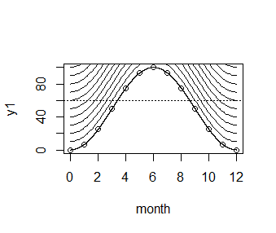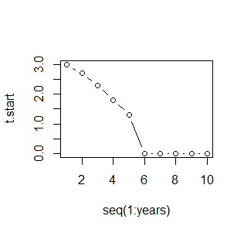

With two resource dimensions that are out-of-phase, there are two interesting possibilities: black low threshold is lower than red high, and red high is lower than black low.

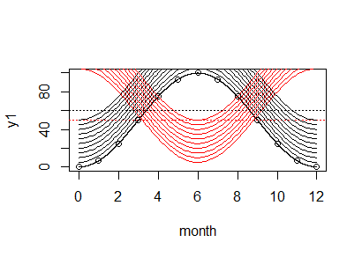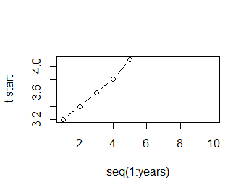

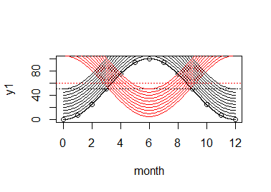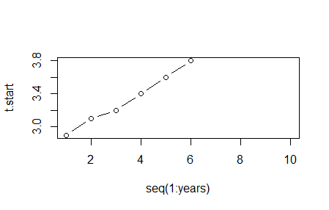

These dynamics are driven by the red curve; the out-of-phase curve with a max line seems like a fairly uncommon scenario (what envir scenario? rain?), but increases in this kind of curve leads to later phenologies, instead of earlier ones.

**April 23, 2012:** Got the main simulation parts running yesterday: initialize the population, selection, reproduction, mutation, and generations. The plotting is working well. Today, I will try to streamline the code, and figure out a way to get the environment to vary, and create a more realistic selection regime.

v. 2012-04-23-01 corrected several bug fixes, including error when t.start > 12; tested with precip data and with SD<1; the population finds the windows of opportunity faster with less mutational variation.

v. 2012-04-23-02 streamlined code with functions preceding script, reduced redundancy

v. 2012-04-23-03 added different forms of selection, including “hard selection” and “soft selection”; still working on a “tunable” version.

v. 2012-04-23-04 minor streamlining with range() function

v. 2012-04-23-05 added tunable inter-annual random environmental variation which affects the cumulative W